1. --- create database

CREATE DATABASE MyWebDB

1. -- create users Table

CREATE TABLE Users

(

UserID int primary key identity (1,1),

EmailAddress varchar(40),

FirstName varchar (50) not null,

LastNmae varchar (60) not null

)

--- create Products Table

CREATE TABLE Products

(

ProductID int primary key,

ProductName varchar (50) not null

)

--- create Download Table

CREATE TABLE DOWNLOADS

(

DownloadID int primary key,

UserID int references Users(UserID),

DownloadDate datetime,

FileName varchar (50),

ProductID int references Products(ProductID)

)

1. ----inserte data into Users

insert into Users

values ('johnsmith@gmail.com', 'John', 'Smith'),

( 'janedoe@yahoo.com', 'Jane', 'Doe'),

('janedoe@yahoo.com' , 'Jane', 'Doe'),

( 'nm@gmail.com', 'North' , 'Man'),

('eg@gmail.com', 'East', 'Girl'),

('ws@gmail.com', 'West', 'Son'),

('mj@gmail.com', 'Mary', 'Jay')

---- insert data into Download

insert into Downloads

values (1233, 01, '2016-03-08 15:17:52:420', 'Petals_are_falling mp3', 121),

(1234, 02, '2016-03-08 15:17:52:420', 'Tun_signal mp3', 122),

( 1235, 03, '2016-03-08 15:17:52:420', 'One_house_town mp3', 123),

(1236, 04, '2016-03-08 15:17:52:420', 'RD', 124),

(1237, 05, '2016-03-08 15:17:52:420', 'TR', 125),

(1238, 06, '2016-03-08 15:17:52:420', 'RA', 126),

(1239, 07, '2016-03-08 15:17:52:420', 'SH', 127)

---- insert data into Products

insert into Products

values (121,'Local Music Vol 1'),

(122,'Local Music Vol 1'),

(123,'Local Music Vol 2'),

(124,'Road'),

(125,'Tree'),

(126,'Ball'),

(127,'Shoes')

1. -- select all data from users table

select * from users

-- select all data from downloads table

select * from Downloads

-- select all data from products table

select * from products

1. --- select query that joins data from the three tables

SELECT U.EmailAddress, U.FirstName,U.LastNmae, D.DownloadDate,

FileName,ProductName

From Users as U

Join Downloads as D

on U.UserID = D.UserID

Join Products as P

on D.ProductID = P.ProductID

**SELECT DOWNLOAD SCREEN SHOT**

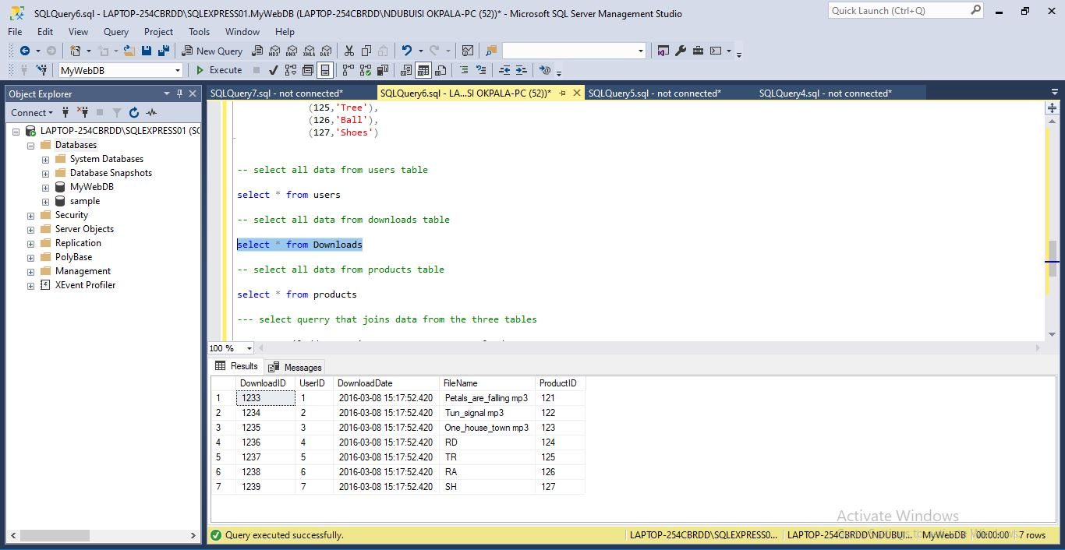

**SELECT PRODUCT TABLE SCREEN SHOT**

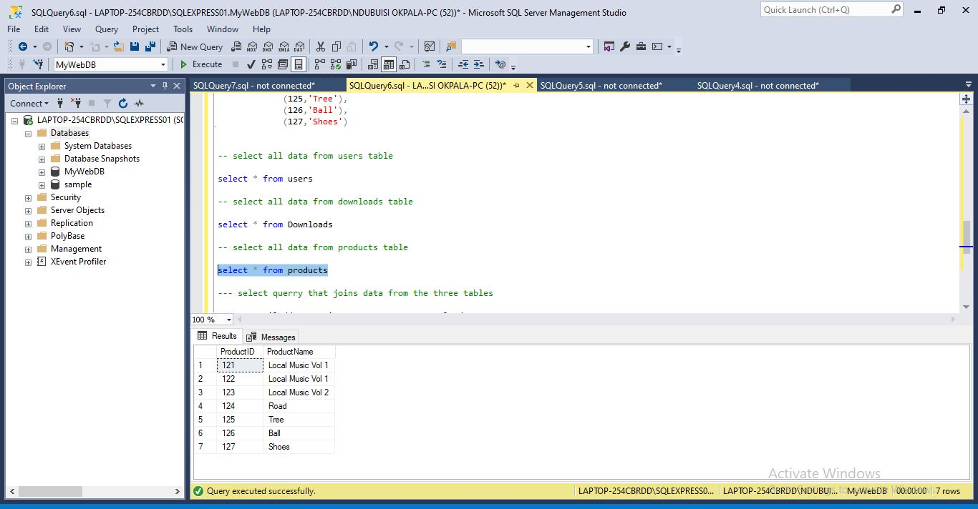

**SELECT USERS QUERY TABLE SCREEN SHOT**

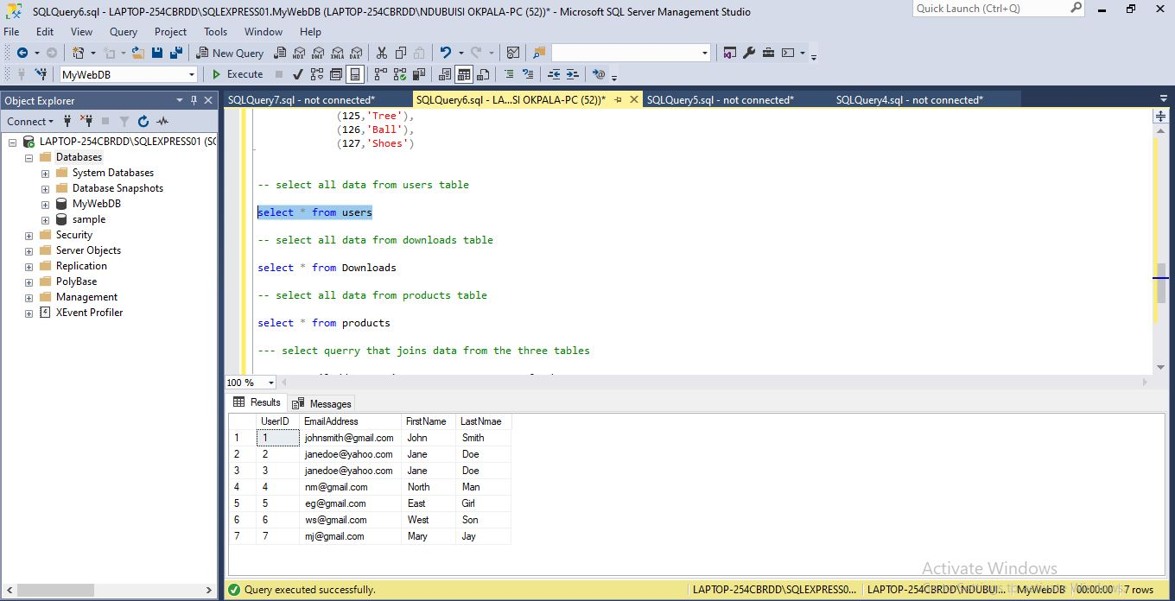

**SELECT QUERY THAT JOINS DATA FROM THREE TABLE SCREEN SHOT**

